Keypad interfacing (port multiplexing)


LAB # 09

Spring 2024
CSE-307L Microprocessor Based System Design Lab

Submitted by: Ali Asghar
Registration No.: 21PWCSE2059
Class Section: C

“On my honor, as student of University of Engineering and Technology, I have neither given nor received unauthorized assistance on this academic work.”

Submitted to:
Dr. Asif Ali Khan

Date:
12th May 2024

Department of Computer Systems Engineering
University of Engineering and Technology, Peshawar

Tasks:
Run the program given in the lecture
Display Numbers from 1 to 9 on the seven segment display and ON the corresponding LED’s attached with P1 Note: Attach the seven segment with P3 and keypad with P1

Code:
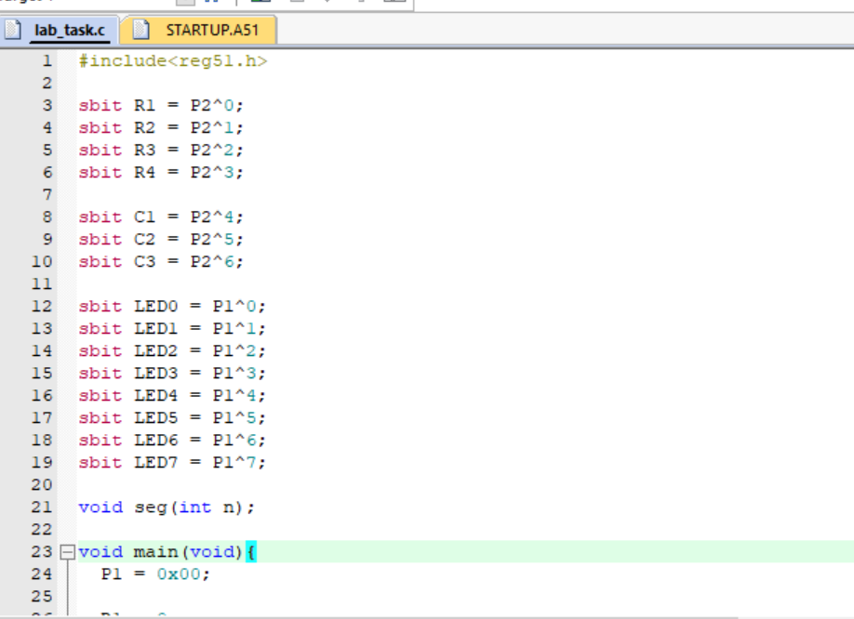
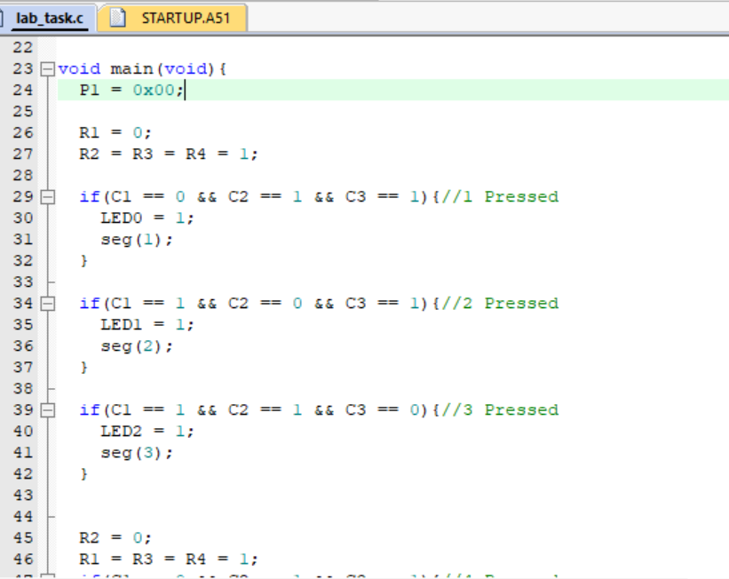
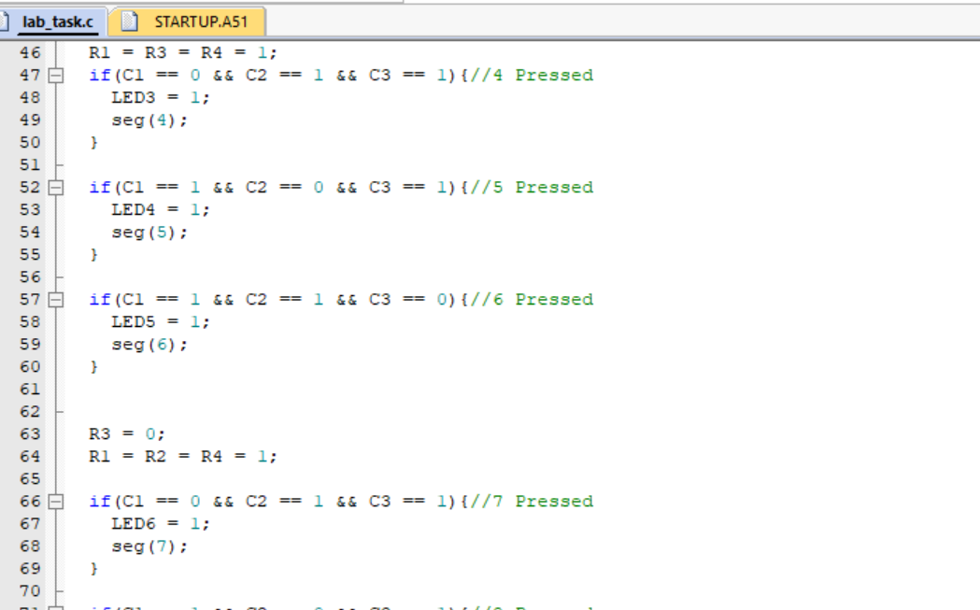
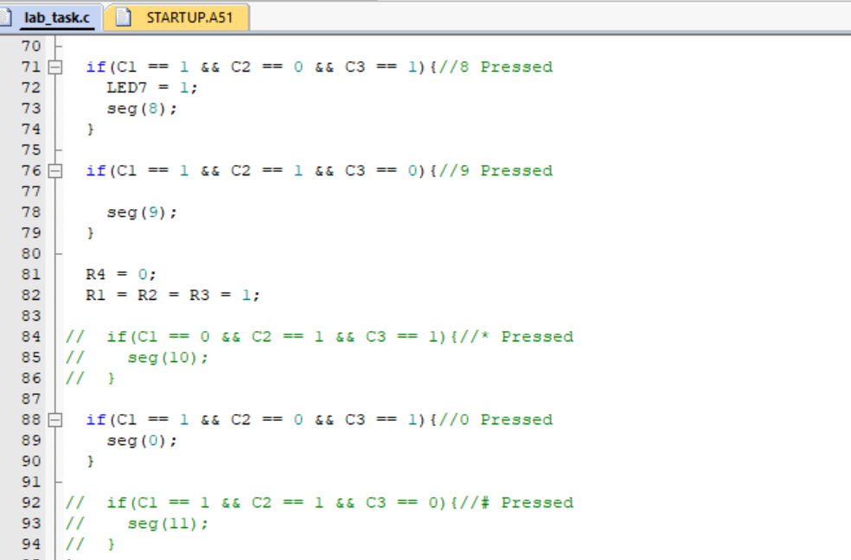
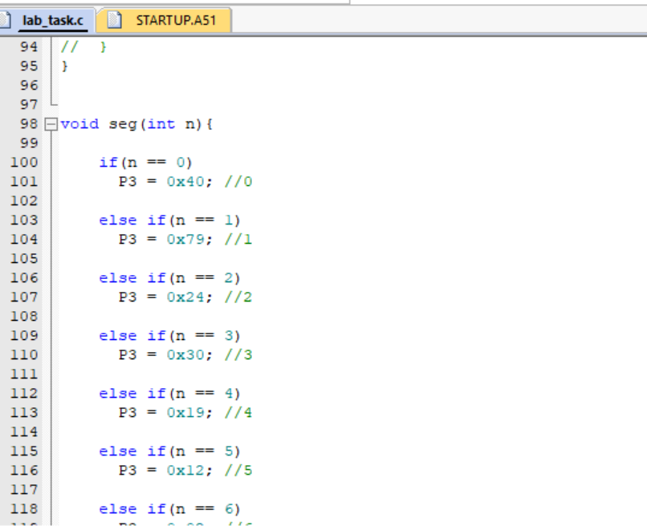

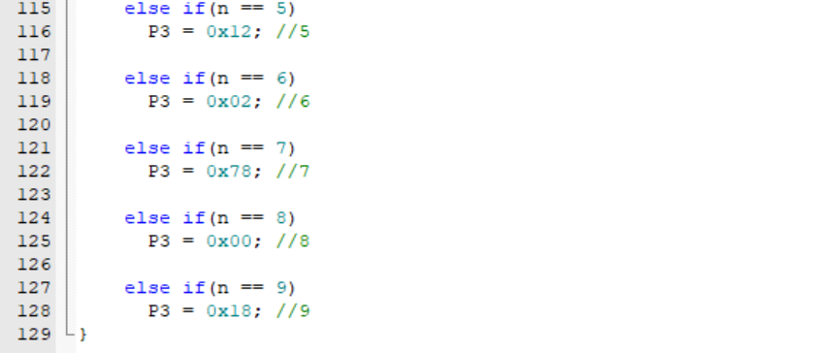

Proteus Simulation:
